Uppdatera länkar till dokumenten och datum i filen .env:
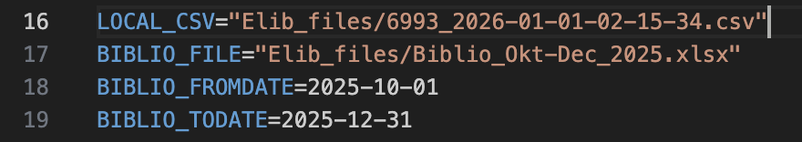

# 0) backup
cp royalty.db royalty_backup_$(date +%Y%m%d_%H%M%S).db

# 1) import wpforms
Exportera relevanta wpforms och ladda upp csv i mappen ” wpforms_exports” (räcker förmodligen med dessa wpforms:
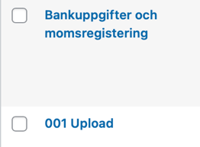
Kör i terminalen:
python src/import_wpforms_authors.py --dir wpforms_exports

# 2) kör royalty (du bekräftar manuellt i terminalen)
python src/main.py

# 2b) plocka senaste RUN_ID
python -c "import sqlite3; c=sqlite3.connect('royalty.db'); print('LATEST RUN:', c.execute('select id, period, created_at from royalty_runs order by id desc limit 1').fetchone())"

# 3) skapa batch (BYT RUN_ID + PERIOD)
python src/create_payout_batch.py --period 2025-Q4 --run-id 12

# 3b) plocka senaste BATCH_ID
python -c "import sqlite3; c=sqlite3.connect('royalty.db'); print('LATEST BATCH:', c.execute('select id, period, run_id, created_at from payout_batches order by id desc limit 1').fetchone())"

# 4) export bankfil (BYT BATCH_ID)
python src/export_pain001.py --batch-id 8

# 5) export bokföring (BYT RUN_ID + VER-DATE)
python src/export_accounting.py --run-id 12 --ver-date 2025-12-31

